# Terms Variable Concept in BEXIS2 – From version 3.0

A tabular and imported dataset is described by a ***data structure***.

A **data structure**:

* must have a name
  + - create from file/ create new: generated & changeable
* can have a description
* must contain a ***variable description*** for each column

Data structure can be created manually or based on an uploaded file.

A **variable description**:

* must have a header name (based on uploaded table)
  + - create from file: read from file
    - create new: by hand
* must have a data type
  + - create from file: suggestion based on file
    - create new: by hand | via template
    - suggestions based on: unit, template
* must have a ***unit***
  + - create from file: suggestion based on file if provided | by hand
    - create new: by hand | via template
    - suggestions based on: datatype, template
* can have a description
  + - create from file: read from file | by hand
    - create new: by hand | via template
* can have ***data constraints***
* can have a ***meaning*** including ***data constraint suggestions\****
* can be based on a ***variable template*** (values are copied and changeable!) including ***data constraint suggestions\****

(*constraint suggestions are copied to data constraints once selected)

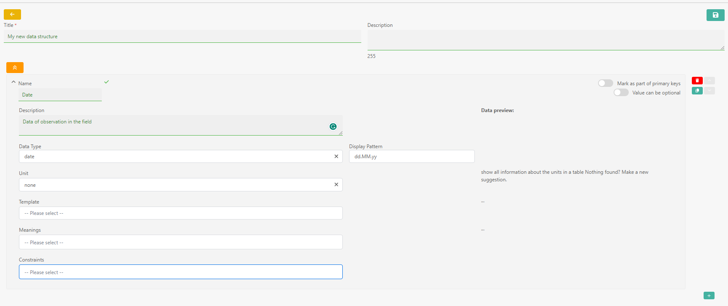

A **unit**:

* must have a name
* can have a description
* must have n allowed ***data types***
* must have a ***dimension***
* must have a selected measurements system
* can have an ***external link*** (e.g. to OM)

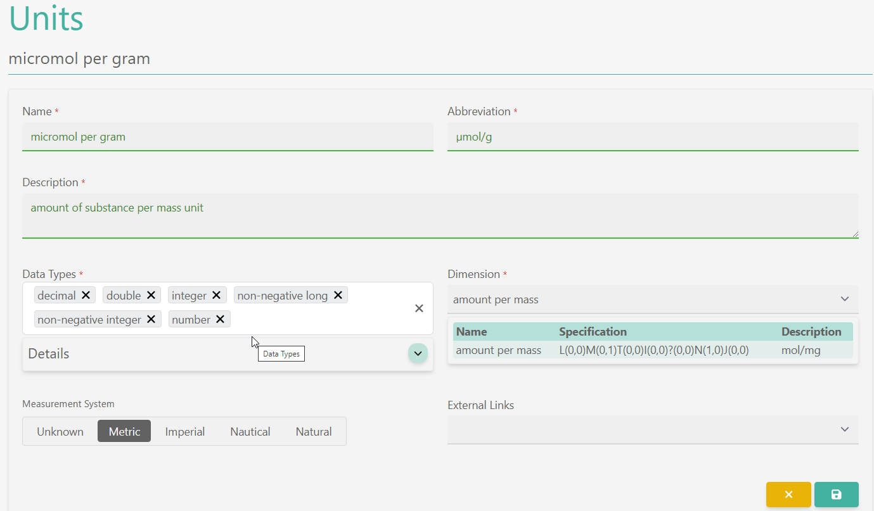

A **data type**:

* must have a name
* must be linked to a system type
* must have a description

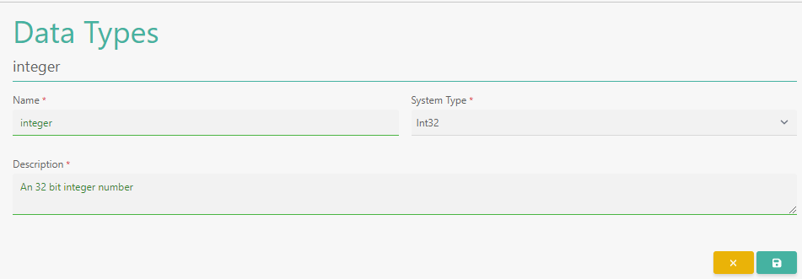

A **dimension**:

* must have a name
* must have a specification following the notation: L(0,0)M(0,0)T(0,0)I(0,0)Θ(0,0)N(0,0)J(0,0)
* must have a description

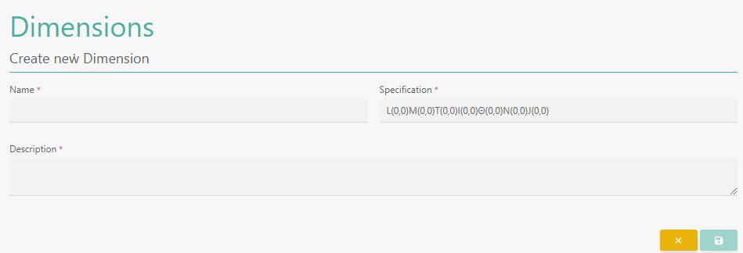

A data ***constraint***:

* must have a name
* must have a description
* must have a type [range, domain, pattern]

**domain** constraints accept a list of values uploaded as file or entered manually. The list is change-/extendable in use.

**range** constraints define a lower and upper boundary of a value

**pattern** constraints are regex expression to check for certain patterns

Data constraints are used to check the primary data during upload. Used constraints are not revalidated after later changes of the definition.

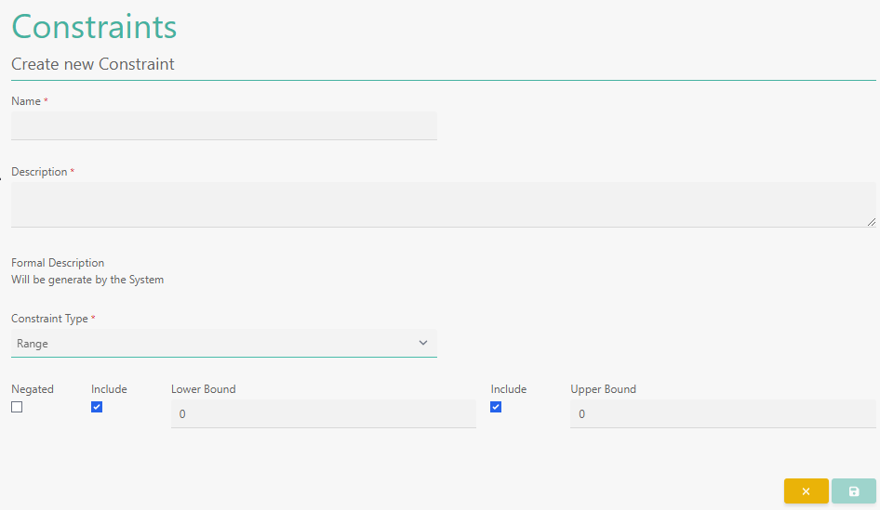

An **external link**:

* must have a name
* must have a type [prefix, entity – class, characteristics – property, vocabulary – dictionary, relationship - connection]
* can have a prefix |a prefix also can have a category [Unit, …]
* must have a uri/iri

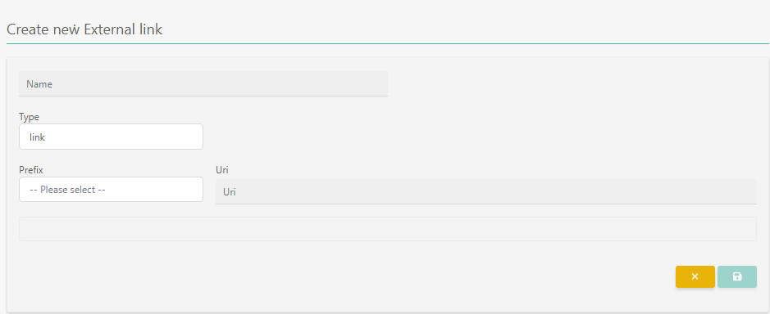

A **meaning**

* must have name
* can have a description
* can be approved | not approved
* can be selectable | not selectable (e.g., to prevent parent nodes can be selected)
* can have n external links connected using a relation (e.g., is hasObjectOfInterest, isProperty)
* can be child of n parents in the future
* can have data constraint suggestions

A meaning describes a variable semantically by a name and description. Meanings can be grouped hierarchically and multiple parents are allowed. It can have multiple references stored under ***external links*** to e.g., vocabularies or ontologies. Each added external link is described by a relation from the associated object in BEXIS2 to the linked resource (e.g., hasObjectOfInterest, hasProperty). This represents a semantic/RDF triple: subject – predicate – object.

The labels of the meaning and of linked resources could be used as keywords to enhance primary data search in the future. Further, using the linked resources, a semantically enhanced search would be possible. It also can help in the future to describe stored variables in a way they are linkable to variables described in other repositories.

